
MODEL PROGRAM:
Off-Road Vehicle Operators Safety Manual
OVERVIEW
Off-Road Vehicle Operators Safety Manual

Purpose
This policy was created to protect our employees from injuries related to the usage of Off-Road Vehicles (ORVs) such as UTVs and ATVs.
Copies of this policy will be accessible to employees at location. Each employee operating a UTV or ATV will be trained on this policy.
Leadership and Accountability
Name or Position will be responsible for annually evaluating the UTV/ATV Operator policy effectiveness and selecting appropriate equipment.
Employees are accountable to know and follow these policies. Employees are also accountable for the proper care, maintenance, and correct use of equipment provided for the job.
Employees should refer questions or comments about this policy to Name or Position.

ORV Operator Qualifications
Employees and volunteers must be qualified before operating a UTV. Qualifications include:
- Being familiar with the "Driver-Operator Guide" and the owner's manual for the UTV they will drive
- Following all local and State operating requirements
- Holding a valid Iowa Driver’s license
- When employees or volunteers complete this course, they will meet all these qualifications.
All operators shall be reevaluated every 3 years by a qualified trainer. Operators must demonstrate their skills and abilities in controls, service, handling, loading, unloading, and operation over local terrain.

Using ORVs
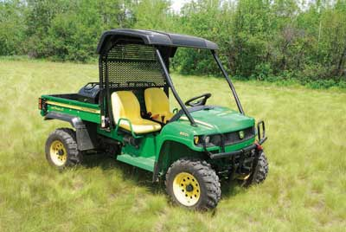
UTVs are motorized off-highway vehicles intended for recreational use and work. Local governments have seen an increase in their usage for general maintenance, rescue operations, and other tasks conducted in hard-to-reach locations.
Before employees use these vehicles, it is critical they understand how to operate them safely. Some of the more serious UTV accidents have included rollovers due to overloading of the UTV cargo bed, altering the cargo bed configuration thereby changing the vehicle's center of gravity, mounting non-baffled tanks to the UTV cargo bed, attempting to climb grades exceeding the capability of the loaded UTV, and operating UTVs on side slopes beyond the vehicle’s design specifications. In some cases, occupants were not wearing their seatbelts and were thrown from the vehicle. Those who were belted in were protected by the rollover protection system (ROPS).
Differences Between UTVs, ATVs, and Highway Vehicles

Features of Utility-Terrain Vehicles
A utility-terrain vehicle (UTV) is a motorized off-highway vehicle designed to travel on four or more tires and carry one or more persons.
Several different companies manufacture UTVs with these features:
- Maximum speed capability greater than 35 miles per hour
- Width less than 80 inches
- Key-operated ignition switch or engine stop device
- Steering wheel
- Two-wheel or all-wheel drive
- Accelerator pedal
- Brake pedal
- Side-by-side seats
- Seatbelts
- Parking brake
- Headlights
- Low pressure tires
- Handholds for passengers
- Tail lights
- Rollover protection system
A rollover protection system (ROPS) is a frame of steel pipe above and around the cab. This system is designed to protect occupants from being crushed during a rollover. A cab enclosure is not a ROPS system unless it is specified in the owner’s manual or on the ROPS itself that it meets SAE J2194 or ASA ES 519 standards. All UTVs purchased by the City/County or operated by employees must be equipped with a ROPS. Studies from the Consumer Protection Commission state that ROPS, when combined with properly fastened seat belts, are 99 percent effective in preventing fatalities and serious injuries in rollovers.

UTVs Compared to ATVs
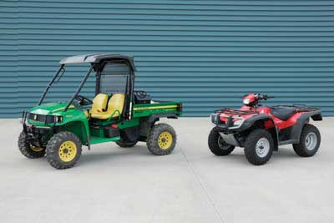
UTVs and all-terrain vehicles (ATVs) have several common features. They both have four or more low-pressure tires, can be two-wheel or all-wheel drive, and have headlights and tail lights. Despite these similarities, there are critical differences between the two vehicles. A UTV has a steering wheel with a sedentary operator while an ATV has handlebars and an active rider, who balances the machine and shifts weight as necessary. A UTV has side-by-side seats, while an ATV has a straddled seat. A UTV can carry one to four passengers, while an ATV is only approved for single riders. A UTV has seatbelts for the operator and all passengers, while an ATV has none. A UTV has handholds for passengers, while an ATV does not. A UTV has an accelerator and brake pedal, while an ATV has a handlebar throttle and a handlebar and footbrake. A UTV has a ROPS, while an ATV does not.

UTVs Compared to Highway Vehicles
UTVs and highway vehicles (figure 10) have several similarities that help the operator learn how to use the vehicle. Similar features include:
- A steering wheel
- Two or all–wheel drive systems
- Side-by-side seats
- Ability to carry passengers
- Handholds for passengers
- Seatbelts
- Accelerator pedal and brake pedal
- Cargo racks and boxes (on some models)
Despite these similarities, operators of UTVs should not drive a UTV like they would a highway vehicle. UTVs are not street legal in all states and they handle differently than highway vehicles. A UTV has low pressure off-highway tires, a high center of gravity, and a smaller wheelbase that makes it less stable than highway vehicles. A UTV is more prone to roll or flip over if driven too fast or steered abruptly.

Safety Requirements

Operational Safety Assessment
Before using a UTV, an assessment must be done to determine the following:
- Identify the tasks or procedures to be accomplished.
- Identify the hazards associated with the tasks or procedures. These hazards may include physical, biological, environmental, chemical, or other hazards. Examples of hazards include:
  - Physical hazards—Rocky terrain and steep slopes
  - Biological hazards—Insect bites
  - Environmental hazards—Weather-related hazards, such as flooding, wind, and lightning
  - Chemical hazards—Hazardous materials, such as gasoline for UTVs
  - Other hazards—Personal security issues, public traffic, and hunting seasons
- Identify abatement actions that can eliminate or reduce hazards. Abatement actions (in order of preference) include:
  - Engineering controls—The most desirable method of abatement (such as ergonomic tools and equipment)
  - Substitutions—Such as switching to nontoxic solvents
  - Administrative controls—Such as limiting exposure by reducing work schedules or establishing appropriate work
  - practices and procedures
  - PPE—The last method of abatement to be considered (such as using a helmet when operating a UTV)

Selection and Use of Personal Protective Equipment
Hard Hat or Helmet?
Operators and passengers shall wear a helmet that meets the requirements of the Department of Transportation or ANSI Z90.1. The helmet must be a full- or three-quarter face motorcycle helmet and worn with chinstrap properly secured. Helmets must be replaced as recommended by their manufacturer or sooner if a helmet is involved in an impact-related accident or shows significant wear or damage. Hard hats are not acceptable for operating a UTV/ATV even though they may be needed at the worksite.
During firefighting operations, a fire helmet may be worn by firefighters instead of a motorcycle helmet.
Other general clothing requirements:
- Long pants.
- Long-sleeved shirt, jersey, or jacket.
- Footwear—Must comply with city/county footwear policy (dependent on where the employee will be working).
- Eye protection—Helmet face shield, safety glasses, goggles, or sunglasses that meet the ANSI 87.1 standard. The specific type of eye protection is determined by the work environment. Eye protection is not required for UTVs with original equipment manufacturer (OEM) windshields that protect the face from branches and flying debris.
- Based on the specific exposures identified in the Operational Safety Assessment, operators may be required to wear other PPE per the city/county Personal Protective Equipment Policy.
- Gloves.
- Respirators for firefighting operations.
- Hearing protection.

Other Equipment
- Fire extinguisher training.
- First aid kit—In addition to the required standard first aid kit, the following items are recommended: rubber gloves, eye protection, and cardiopulmonary resuscitation (CPR) clear-mouth barrier. It is also recommended to enclose the first aid kit in a zip lock bag or other dust proof container.
- Personal communication device—A two-way radio, cellular phone, or satellite phone. Select the device based on the area, terrain, and reception reliability.
- Owner’s manual and manufacturer’s toolkit (figure 18)—Include a tire pressure gauge for the appropriate pressure range.

Pre-use Inspection

T-CLOC Check
A pre-use inspection must be performed before an operator uses an ORV. This inspection ensures the ORV is in proper operating condition. Use the T-CLOC check:
- Tires and wheels: Check the air pressure and condition of the tires. Check the rim bolts, axle nuts, and wheel bearings.
- Controls and cables: Locate and check the operation of the controls. Check the brake pedal adjustment and fluid level. Inspect the shifter.
- Lights and electronics: Check the lights. Check the ignition switch and engine stop switch. Ensure all the gauges are functional.
- Oil, fuel, fluids, and air filter: Check the oil, fuel, and coolant levels. Inspect the machine for leaks. Ensure that the air filter is clean, not torn or blocked.
- Chassis, suspension, driveshaft, and external equipment: Check the underside of the UTV for damage. Shake the chassis and suspension system to be sure nothing is loose and that the shocks are operating properly. Check the cargo boxes and racks for cracks and ensure that the fasteners are tight and secure. Check the drive shaft for oil leaks or missing nuts and bolts. If the UTV has a winch, inspect it for damaged cables, fairleads, hooks, and controls. If the UTV has a trailer hitch, make sure it is secure and the proper size and capacity. Finally, ensure that toolboxes and other equipment are in good condition, properly loaded, and secure. If the UTV has a mounted piece of industrial equipment, ensure that the regional engineer or designee has approved the addition.

Transportation

Loading, transporting, and unloading.
Towing Vehicles
If a UTV is to be towed, the weight of the towing vehicle and loaded trailer must not exceed 75 percent of the Gross Combined Weight Rating (GCWR). Refer to IDOT on Double Towing requirements and General Towing laws.
Trailers
UTVs must be transported on a trailer. They cannot be transported in the bed of pickup trucks. A tilt-bed trailer, especially designed for hauling off-highway vehicles, is the best unit for hauling these machines but others may be used. All trailers must be in good condition and have the proper gross vehicle weight rating (GVWR), the trailer’s maximum allowable weight when loaded. The weight of your trailer and your load must never exceed the trailer’s GVWR.
ATVs may be transported in a truck bed.
Loading and Unloading UTVs
- Passengers must get out.
- Use a spotter to assist in loading whenever possible.
- Remove any portable cargo or equipment and empty any liquid tanks to remove weight from the back of the UTV. If heavy cargo or tanks cannot be emptied or removed safely, secure sandbags or other heavy objects to the front of the UTV to equalize the load. If the load cannot be balanced, the UTV can be winched onto the trailer without an operator on board.
- A winch can also be used to load a disabled UTV. Before winching, operators should be trained and fully aware of serious hazards associated with winching operations. Appropriate PPE must be worn during winching operations.
- To load a UTV, fasten your seatbelt and remain seated. Injuries are more likely to be serious if you are thrown from the machine. Apply the accelerator pedal smoothly. Listen and follow the spotter’s directions. Climb the ramp at a low speed. Too much speed or sudden acceleration may cause the UTV to overturn, slam into the front of the trailer, or overshoot the front of the trailer.
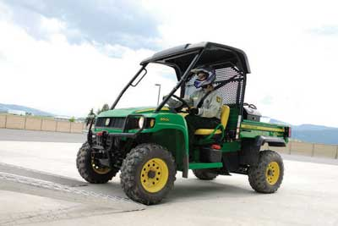
- When a UTV has been loaded, turn off the ignition, remove the key, put the transmission in the recommended gear (in the owner’s manual), and set the parking brake. Secure the UTV to the trailer with four tie downs: two in front and two in back (see owner’s manual).
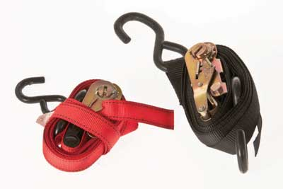
- Secure the tie downs to the trailer’s cargo anchors and the UTV frame tubing (not the cargo racks) unless the owner’s manual indicates otherwise. The tie downs will prevent the machine from moving while it is being transported. If a commercially manufactured restraining device is available, only two tie downs may be used. All tie downs must be ratchet type, in good condition, free of frays and splices, and have a minimum weight capacity of 2,500 pounds. Do not use knotted straps or ropes to secure a UTV.

To unload a UTV, apply the accelerator pedal just enough to start the UTV down the ramp. Allow the UTV to roll down the ramp using light brake pressure to control the speed (figure 35). Hard braking when descending a ramp could cause the UTV to flip over.
Safe Operating Practices

Loading Cargo
Cargo and trailers affect how a UTV handles. Before hauling cargo or towing a trailer, consult the UTV owner's manual to determine weight limits. Do not exceed the gross vehicle weight rating, the trailer's gross vehicle weight rating, or the weight rating of the trailer hitch.
When loading cargo, keep the cargo centered and as far forward as possible. Place heavier objects on the bottom and lighter objects on the top to keep the UTV or trailer from being top heavy, increasing the risk of rollover. Consider making two trips when you are transporting a lot of cargo or heavy cargo, especially in rough terrain. Secure the cargo with a net, bungee cords, straps, or ropes (figure 38) to prevent it from shifting. You could lose control of the UTV if the cargo shifts while you are traveling.
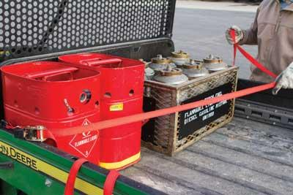
Take extra precautions when carrying liquid (figure 39). When a liquid sloshes back and forth, weight shifts on the UTV which could affect its center of gravity. Ensure that tanks carrying liquid do not exceed the load carrying capacity for the UTV. Tanks with baffling devices are highly recommended to reduce sloshing and shifting of weight.

Figure 38—An employee secures cargo with a tiedown strap.
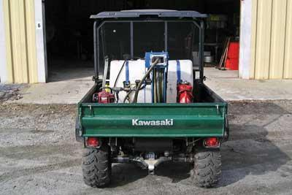
Figure 39—UTV equipped with a water tank.
Emergency Transportation of Passengers
No one is allowed to ride in the bed of a UTV unless it is to evacuate an injured person when no other form of vehicle is an option for the transport.
Towing Loads with UTV/ATV
Before towing any trailer, sled or dragging a load, the operator will consult the owner’s manual for load limitations. Operators should consider the load weight, terrain and grading to develop a route.
The operator shall also inspect the trailer ball/hitch to ensure they are in good condition and suitable for the task. All tow straps should also be inspected before use.

Safe Driving
Before Starting
Consult with the owner's manual before operating a UTV. Make sure that the manufacturer's recommended maintenance and service have been performed.
If a UTV has an adjustable suspension system, a qualified mechanic or certified dealer can adjust the suspension for the work conditions. A softer suspension setting is needed for rougher terrain. The right and left shocks must be set the same to avoid poor handling.
If a UTV has the option for two-, four-, or six-wheel drive, determine which setting is best suited for the trail conditions and terrain. Steering is easiest in two-wheel drive, but a UTV generally handles rough terrain and obstacles better in four- or six-wheel drive. Inexperienced operators may need to practice their driving skills in two-, four-, or six-wheel drive before knowing which setting is right for the conditions.
Before starting a UTV, make sure your seatbelt is securely fastened. If the seatbelt is adjustable, move it until it's comfortable and then follow the manufacturer's instructions for securing it.
Become familiar with your UTV gauges and controls, because each make and model may be different. UTV gauges may include a speedometer, fuel or hour gauge, and a low-oil light. UTV controls may include an accelerator pedal, brake pedal, shifter, parking brake, and light switch.
Startup
Before starting a UTV, make sure the parking brake is engaged and the transmission is in "neutral" for manual transmissions or "park" for automatic transmissions. Turn the lights on to increase visibility of the UTV.
To start some gas-powered UTVs, a key is inserted and turned to the "on," "run," or "start" position. On other models, a "start" button may have to be pushed after the key is turned "on." For machines with a carburetor, the choke will have to be closed for starting and then opened to run. For many electronic UTVs, the machine is started simply by turning the engine stop switch to "run" or "on."
Getting Going
To get going with an automatic transmission, press the brake pedal, shift into gear, and release the parking brake. Press the accelerator pedal slowly. For manual transmissions, press the brake pedal and clutch, shift into the lowest gear, and release the parking brake. Release the clutch slowly while pressing the accelerator pedal slowly.
While operating a UTV:
- Always remain seated with a seatbelt on.
- All passengers must wear a seatbelt while riding in the UTV.
- Be aware that passengers affect how the vehicle handles.
- Keep your eyes on the trail and hands on the wheel.
- Avoid distractions such as eating, drinking, using a cell phone or radio, or reading a map.
- Operate the UTV at safe speeds within the limits of the machine and the operator's skills.
  - Speeds exceeding 8 miles per hour are considered dangerous (Driver-Operator Guide).
- Assess terrain before crossing it.
- Reduce speeds when hauling heavy cargo.
- Keep alert for signs of vehicle defects, such as unusual noises or vibrations, and take immediate action (during operation check).
SIPDE Process
The SIPDE process is a system taught in driver education classes. SIPDE stands for:
S—Sweep, Search, and Scan: The operator must continually glance from side to side and scan the surrounding area for hazards that may affect the operator, the passengers, or the operation of the machine.
I—Identify: The operator must be able to identify whether an object, animal, or situation poses a hazard to the operator, the passengers, or the operation of the UTV.
P—Predict: The operator must be able to predict whether the identified hazard will affect the operation of the machine, operator, or passengers. Specifically, the operator must predict the worst-case scenario and determine possible courses of action.
D—Decide: The operator must choose a safe course of action that will mitigate the hazard.
E—Execute: The operator must execute the mitigation.

ORV Recovery
If a vehicle is stuck or inoperable, operators shall be trained to properly use any attached winches if attempting extrication. This will include assessing anchor points for the winch or hooking up tow straps to the ORV for assisted towing.

State and Local Regulations
Link to Iowa Department of Natural Resources Off-Highway Reference Guide
https://publications.iowa.gov/15952/1/OHV%20Reference%20Guide.pdf
Definitions
- Off-road utility vehicle (ORV) means a motorized vehicle with not less than four and not more than eight nonhighway tires or rubberized tracks that is limited in engine displacement to less than 1,500 cubic centimeters and in total dry weight to not more than 2,000 pounds and that has a seat that is of bucket or bench design, not intended to be straddled by the operator, and a steering wheel or control levers for control. A motorized vehicle that was previously titled or is currently titled under Iowa Code Chapter 321 shall not be registered or operated as an off-road utility vehicle.
- Public land means land owned by the federal government, the state of Iowa, or a political subdivision of the state and land acquired or developed for public recreation pursuant to Iowa Code §321I.8.
Registration Requirements
- Each OHV in Iowa used on public land or ice, a designated riding area, or a designated trail of this state must be currently registered with the IDNR. A person shall not operate, maintain, or give permission for the operation or maintenance of an OHV on public land or public ice unless the OHV is registered in accordance with the laws and administrative rules of Iowa or applicable federal laws.
- Exempt Vehicles Registration is not required for the following OHVs:
  - A vehicle owned by the United States, this state, or another state, or by a governmental subdivision of a state and is used for:
    - Enforcement
    - Search and rescue
    - Official research and studies
    - OHVs used exclusively for agricultural purposes.
Laws of Interest
- In a careless, reckless, or negligent manner so as to endanger the person or property of another or to cause injury or damage thereto.
- While under the influence of intoxicating liquor or narcotics or habit-forming drugs.
- A person shall not operate a vehicle with more persons on the vehicle than it was designed to carry. This requirement does not apply to a person who operates a vehicle as part of a farm operation as defined in Iowa Code §352.2.
Age Limits
- Ages 12 through 17 – must have a valid ATV education certificate in their possession. The supervision rule does not apply to these riders.
- Eighteen and older – operation is only affected if the person’s privilege to operate a motor vehicle has been revoked or barred. If operation is on a roadway, then suspension of the person’s privilege to operate a motor vehicle also applies.
- Operating with a passenger – if operating an ATV which was manufactured to carry a passenger, the operator must possess a valid driver’s license as defined in Iowa Code §321.1.

Authorized UTV/ATV Operators
First Name | Last Name | Department | Date of Training | DNR Certificate Number

Operator Skill Training
All operators shall undergo the skill training as set out in ORV Operator Skills Manual.

