Firefighters
Model Rehabilitation Standard Operating Procedure
for
Entity Name

Adopted: _______________________

Last Reviewed: _______________________

TABLE OF CONTENTS

Purpose 3
Scope 3
Responsibilities 3
Rehabilitation providers 3
Location for rehabilitation activities 3
Baseline information for rehabilitation activities 4
Rehabilitation team members 4
Supplies needed for rehabilitation 5
Guidelines for rehabilitation 6
Sample form A 7
Sample form B 8
Sample form C 9
Sample form D 10
Appendix A 11
Appendix B 12

Purpose
This program was created to ensure the safety and health of members of the [insert the name of your entity fire and rescue] while operating at the scene of an emergency or training exercises.

Scope
This program shall apply to all operations and training exercises where strenuous physical activity or exposure to heat and cold exists.

Responsibilities

The incident commander shall consider the circumstances of each incident and make provisions early in the incident for rest and rehabilitation for all members operating at the scene.

Supervisory level personnel shall be responsible for monitoring the condition of each member to ensure that adequate steps are taken to provide for health and safety of each member. Supervisory level personnel shall be responsible to ensure each member follows the prescribed procedures of this policy.

Members operating at a scene shall keep their command personnel advised of their need for rest or rehabilitation. They shall also be aware of the health and safety condition of the other members of the department or crew. All members entering the incident scene shall check-in/check-out at the rehabilitation site and register on Form D.

Rehabilitation providers

When the circumstances of an incident warrant the need for a rehabilitation operation, the incident commander will call for the [insert the name of the EMS team here] to supervise and operate the rehabilitation activities for the incident.

If a city or department does not have an EMS unit available within the city or jurisdiction, the department can develop agreements with neighboring EMS units or may designate qualified individuals within the department to supervise rehabilitation operations. If individuals from the department are designated to supervise rehabilitation operations, they shall be completely committed to rehabilitation throughout the incident.

Location for rehabilitation activities

In establishing a rehabilitation operation for an incident site, the following criteria must be considered when designating a location:

- Must be away from the fire or hazardous area,
- away from the action,
- sheltered from adverse climate conditions,
- large enough for safe removal of bunker gear and SCBA’s ,
- large enough for ambulances to move in and out,
- near the air supply or where empty oxygen cylinders are exchanged for full ones,
- away from exhaust fumes of trucks, and
- have adequate room to accommodate multiple crews.

If the department has a separate emergency vehicle designated for this use, please identify it here.

- Designated Emergency Vehicle used as rehabilitation center or supply site:

Equipment/ Unit Description | Number

Baseline information for rehabilitation activities

To provide members with the best care possible, the department shall maintain copies of Rehabilitation Medical Information sheets for each member and have that information available at each site where the incident commander establishes a rehabilitation operation. See Sample Form A.

Rehabilitation team members

Members qualified to provide rehabilitation operations:

Name of Member | Member Qualification Level

Supplies needed for rehabilitation

- Equipment bag
- Tarp or flag to designate rehabilitation area
- Clipboards, pens and post-it notes
- Phone book/staff phone numbers
- Rehabilitation notebook with baseline vitals
- A watch with a second hand
- Hand held radio
- Tympanic thermometer
- Blood pressure cuff and stethoscope
- Sports drinks
- Water without ice (if cold use coffee)
- Pulse ox
- Towels
- Ice packs/warm packs
- Food, if prolonged scene time
- Disposable drinking cups
- Garbage bags
- Ice chest with ice if possible
- Oxygen and airway adjuncts
- Scissors
- Flashlight
- Hand sanitizer
- Key to rehabilitation storage
Guidelines for rehabilitation

- All firefighters shall be checked-in at rehabilitation center (See Form D)

- Following the first SCBA bottle, firefighters shall be visually and verbally checked in the staging area (See Form B and C)

- Following the second SCBA bottle, firefighters shall report to rehabilitation for a minimum of 30 minutes for second visual and verbal check and rest.

- In rehabilitation, firefighters are to sit down and rest, take helmet and coat off and loosen or pull-down pants.

- If it's hot use cool compresses around the neck, under arm pits and drape over the head. Do not move the firefighter into air conditioning. Fluid replacement should consist of water or sports drink. NO ICE! Drink fluids slowly (See Appendix A).

- If it’s cold use blankets, go into a squad vehicle, other designated vehicle or near a building (See Appendix B).

- Monitor vital signs every 15 minutes.

- Notify the rehabilitation officer or transport to emergency room if:

− Diastolic blood pressure (BP) is above 130.
− Diastolic BP is above 110 and symptomatic.
− Diastolic BP is below 110 and symptomatic.
− Systolic BP is above 200 after resting.
− If heart rate, after 30 minutes of resting is above 140.
− If body temperature is below 95°F or above 100°F.

ANY PERSON COMPLAINING OF CHEST PAIN, SHORTNESS OF BREATH OR ABNORMAL VITAL SIGNS MUST BE REMOVED FROM THE SCENE!

Sample form A

Date: ______________ Patient’s Last Initial:

Rehab Medical Information
(Please Print)
Department ________________________________
Personnel # ________________________________
Name _____________________________________
Birthdate ___________________________________
Age _____________________________________
Doctor _____________________________________
History
Current Medications Allergies Medical Conditions
_________________ _________________ _________________
_________________ _________________ _________________
_________________ _________________ _________________
_________________ _________________ _________________
Resting Baseline Vitals
Date _____________

B/P _____________ Resp _____________ Pulse _____________ (Regular/Irregular)
Date _____________
B/P _____________ Resp _____________ Pulse _____________ (Regular/Irregular)
Date _____________
B/P _____________ Resp _____________ Pulse _____________ (Regular/Irregular)

Comments:
____________________________________________________________________________________________________________________________________________________________

Sample form B
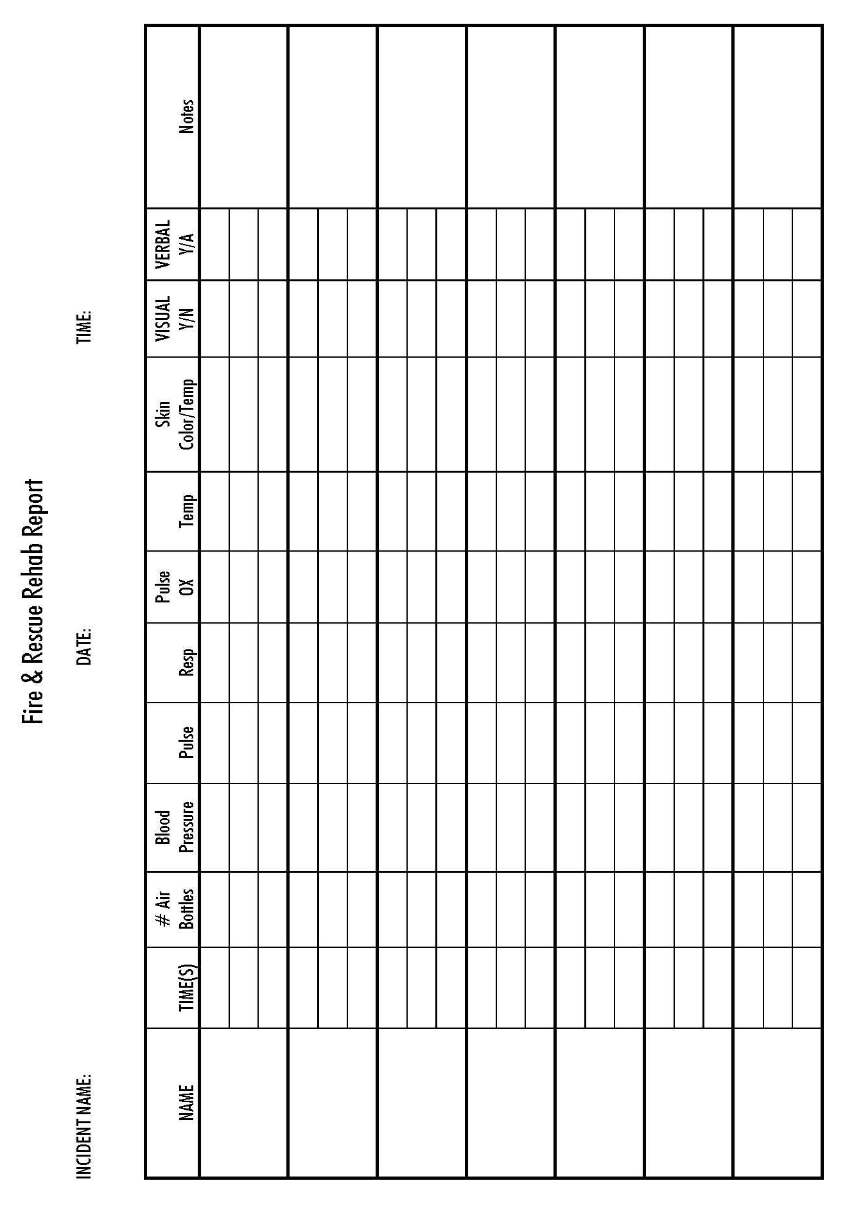
Sample form C

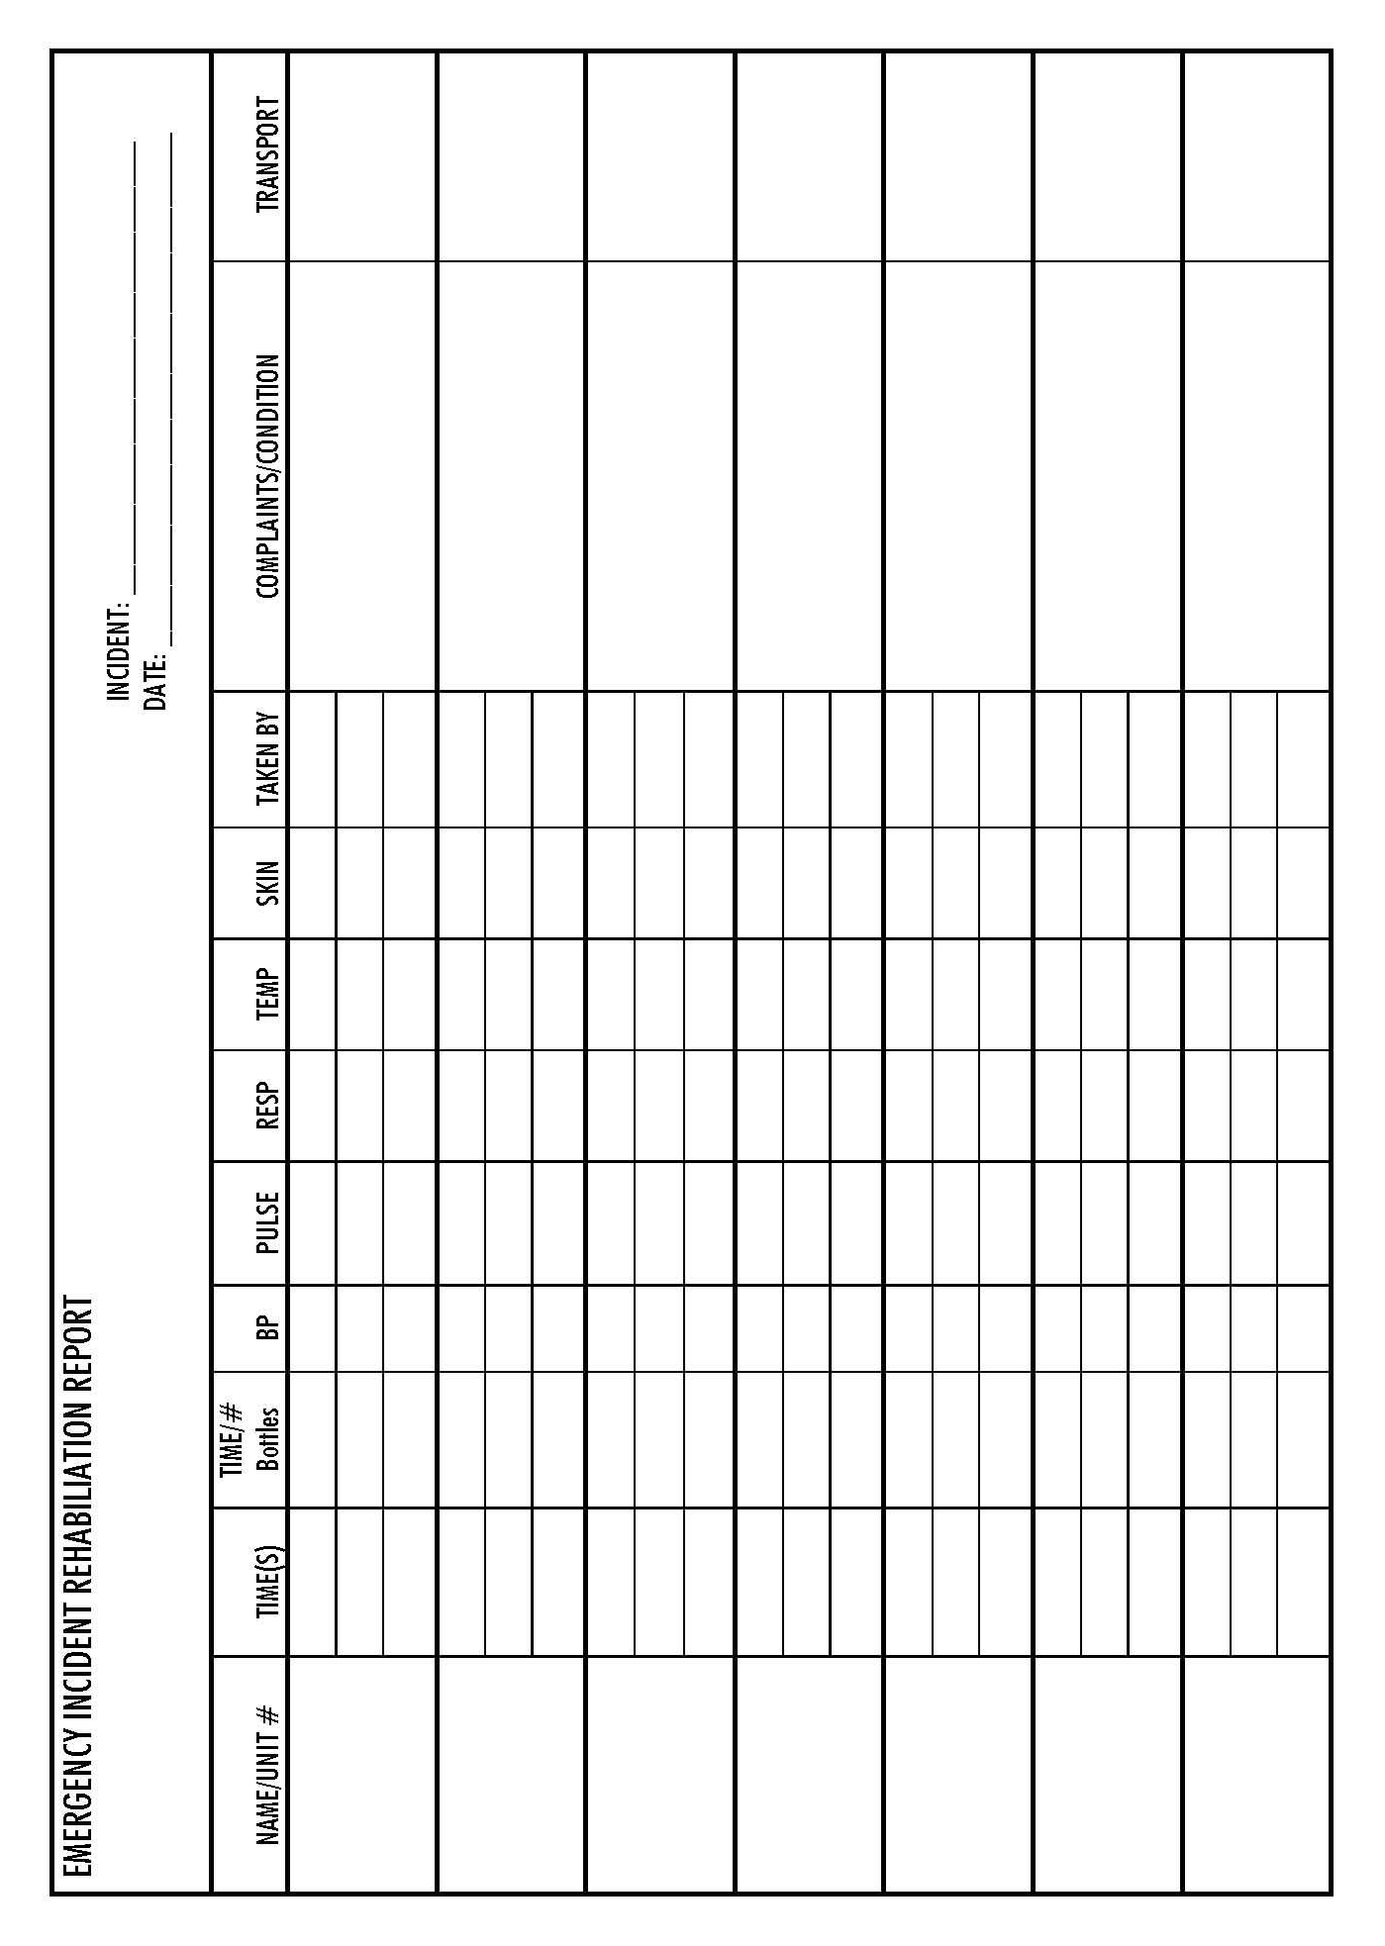
Sample form D
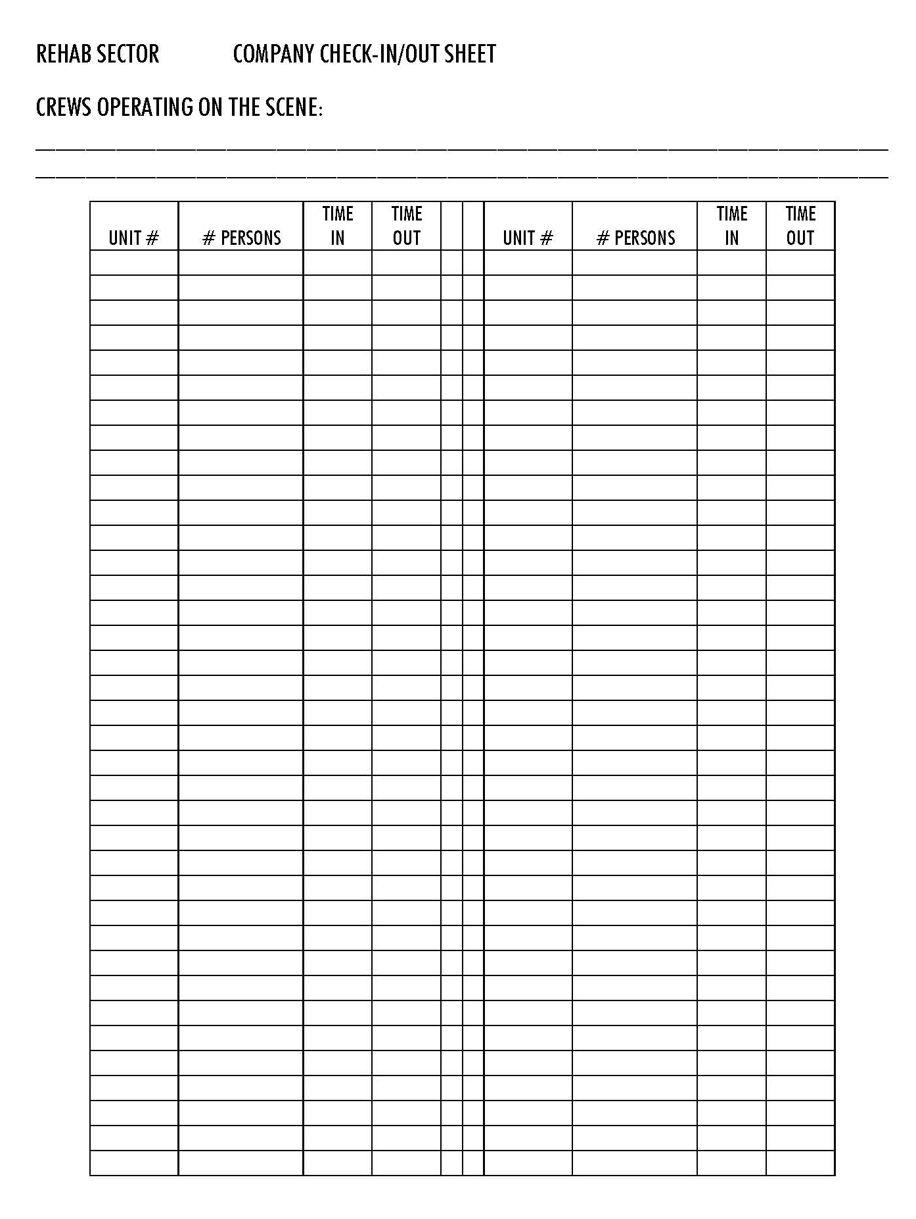

Appendix A
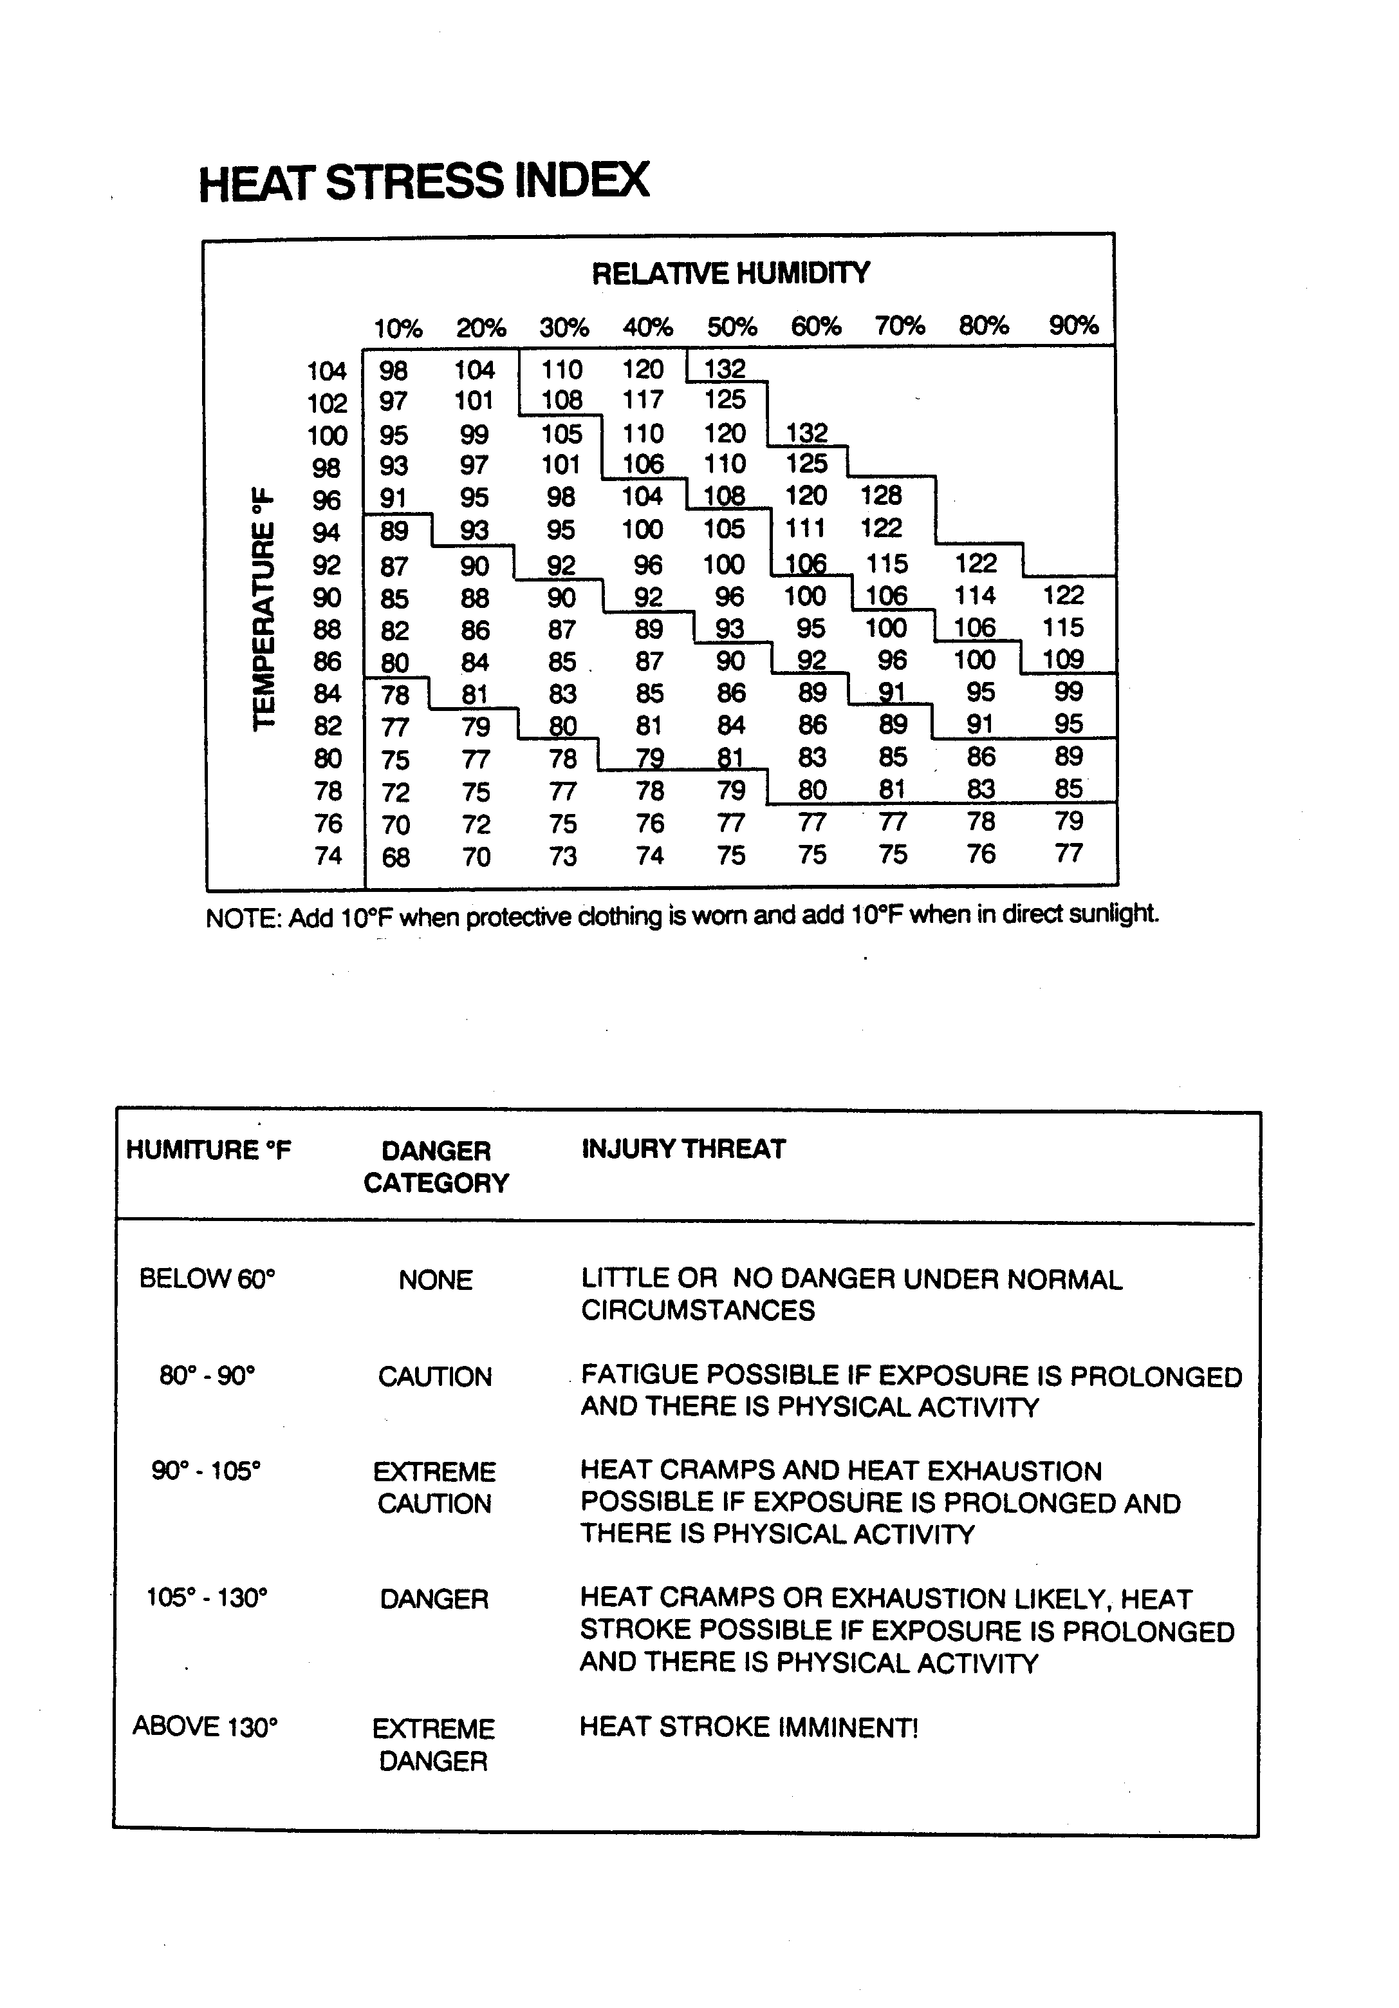
Appendix B

