
Chain Saw and Tree Felling Program

OVERVIEW

Purpose 1
Leadership and Accountability 1
Key Definitions 1
Employee Information and Training 2
Safety Features of Chain Saws 2
Personal Protective Equipment 3
Felling Requirements 5
Felling Procedures 6
Limbing a tree 7
Medical Availability 7

chain saw and tree felling program

Purpose
This policy was created to protect our employees from hazards they may encounter while operating chainsaws such as amputations and crush injuries while they remove trees.

Copies of this policy will be accessible to employees at location. Each employee operating a chainsaw and involved in felling and removing trees and debris will be trained on this policy.

Leadership and Accountability
Name or Position will be responsible for annually evaluating the Chainsaw policy effectiveness and selecting appropriate equipment.
Employees are accountable for knowing and following these policies. Employees are also accountable for the proper care, maintenance, and correct use of equipment provided for the job.
Employees should refer questions or comments about this policy to Name or Position.

Key Definitions
Brushing. Removing brush and shrubs to clear out an area. Cutting tree and brush material that is less than 8 inches in diameter and less than 10 feet in height.
Bucking. Sawing trees and limbs into shorter lengths.
Escape route. An “escape path” and an “alternate path.” Each path should lead diagonally away from the expected felling line (forming a 45-degree angle between the two clear pathways) directly into the safe zone.
Operator. A person authorized to fell trees.
Felling. Cutting down trees and brush materials that are over 10 feet tall or greater than 8 inches in diameter, or both.
Limbing. Removing the branches from a felled or standing tree.
Safe zone. An area away from the tree you plan to fall and in the quadrant opposite the planned fall direction of the tree. The escape path and the alternate path lead to the safe zone.

Employee Information and Training
The employer shall provide training so that all employees who may use chain saws as part of their duties and ensure they can demonstrate proficiency before they operate a chain saw. All training must be documented.
  - See IMWCA Online training

Employees felling trees and brush shall also be trained on the proper techniques for felling, bucking and limbing trees.

Safety Features of Chain Saws
Operators may only use chain saws that meet the following specifications (also see Figure 12-1):
- Chain saws that are maintained in a serviceable condition.

- Chain saws that comply with OSHA’s 29 CFR 1910.266 to include the following safety components:

  - The Right Chains. Use the right chain for the job. Consider the complexity of the cut, the saw, and operator skill level (e.g., low kick-back chain for less experienced sawyers or skip-type chain for larger trees and more experienced sawyers).

  - Chain Brakes. Test the chain breaks before each use. Apply chain brakes when you start the saw.

  - Anti-Vibration Device(s). Consult the owner’s manual. All saws manufactured after 1991 should have this built into the saw.

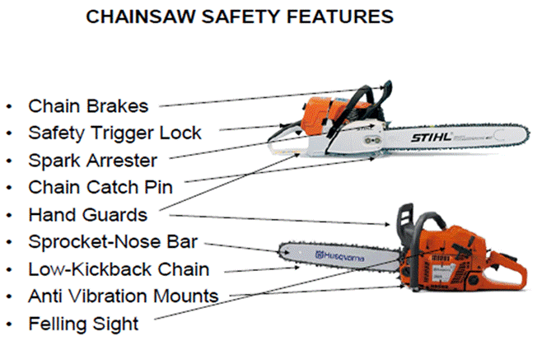
  - Safety Trigger Lock. This lock prevents the throttle from engaging unless a throttle interlock is depressed on the handle.

  - Chain Catch Pin. This pin is on the underside of the saw below the base of the bar. It stops the chain from being expelled if the chain breaks.

  - This device is on the exhaust system and reduces the fire hazard.

  - Carrying Case or Chain Guard. Use either a case or a guard to transport and store the saw to protect you and others from injury.

  - Hand Guards. These guards are on the throttle handle and chain saw guide handle (they may be incorporated with a chain brake).

Personal Protective Equipment

- Supervisors must issue all required PPE to chain saw operators prior to chain saw use.

- All PPE must be designed and constructed for the work you perform.

The Supervisor must:
- Either the operator or another designated employee must maintain all equipment in serviceable condition according to the manufacturer’s operating manuals and maintenance instructions. The operator must always inspect equipment before use during each work shift.

What PPE must operators use:
PPE | Required types | Other Essential Information
A. Hand protection | · Wear quality leather gloves consistent with weather conditions.  · Do not use gauntlet-type gloves.  · Wear anti-vibration (padded palm) gloves for long-duration cutting projects. | · We recommend cut-resistant Kevlar or ballistic nylon gloves for operators who use a chain saw frequently.
B. Eye and face protection | · Wear ANSI Z87.1-approved eye protection (safety glasses or shield). | · Recommend wearing a logger type mesh screen attached to your helmet; safety glasses or goggles alone do not protect your face.  · You can use clear shields, but they scratch easily and fog up in humid conditions.
C. Head protection | · Wear ANSI Z89-approved type I, class “E” and “G” hard hat.  · Inspect the hard hat before use and replace it according to the manufacturer’s specifications. | · The hard hat must display an annotation that it meets the ANSI standard.
D. Hearing protection | · Wear ear plugs, ear muffs, or both. | · Properly fitted ear plugs provide the greatest level of noise reduction, and muffs can provide additional protection from cuts from brush.  · Some saws operate at higher decibels, and if you operate the saw for extended periods, you may need to use double hearing protection.  · Chain saw operation falls within the OSHA hearing loss prevention standards.
E. Foot protection | · Wear heavy duty Steel toed leather or cut-resistant boots that:  -Cover and support your ankles,  (we recommend 8-inch-high laced boots that are waterproof or water repellant), and  -Have nonskid soles with adequate treads for the conditions. | · We recommend cut-resistant Kevlar or ballistic nylon logger boots for operators who use a chain saw frequently. These boots provide better protection from a direct strike of the chain.
F. Leg protection | · Wear cut-resistant logger chaps made with Kevlar or ballistic nylon.  · The chaps must:  -Cover the full length of the thigh, to 2 inches below the top of the boot, provide ¾ (leg front and side) coverage, and allow no gaps between the top of the boot and the chaps. | · Almost 50% of chain saw injuries occur to the legs.  · Logger pants are also available for maximum protection. These pants provide better protection than the standard logger chaps and are more comfortable to wear in hot weather than the full coverage type chaps.  WARNING: Additional operator caution is necessary when using an electric chain saw because chap fibers will not stop the higher constant torque. You must also consider electrocution hazards.

Felling Requirements

- Risk Analysis. All chain saw operators, regardless of experience or qualifications, must thoroughly analyze tasks to determine if the level of risk is acceptable. If the level of risk is not acceptable, the operator must walk away. Operators should consider alternative solutions to risky operations, such as using heavy equipment, a contractor, or explosives. Also, seek guidance from experienced sawyers.

- Working Alone. All chain saw operators must work in a position or location that is within visual or audible contact with another employee/operator. Chain saw operators who must perform work alone that is not covered under the logging standard, such as incidental work to remove a single tree or limbs blocking a roadway passage, must:

(1) Be trained in evaluating complex bucking, sawing, and felling conditions and in hazardous tree operations;
(2) Have adequate radio or cell phone communications;
(3) Notify someone in the administrative office when work will begin; and
(4) Establish a check-in procedure for when the task is complete.
- Observers and Spotters. No employee may approach an operator closer than 2 times the height of the trees being felled until the operator acknowledges that it is safe to do so, unless a team of operators is necessary to fell a particular tree. The lead operator will determine if spotters are needed during tree-felling operations.

- Escape Routes. These are predetermined paths of exit used by the operators when felling or bucking. The essential components of an escape route are selection of the desired direction and distance before felling or bucking, and a well cleared path through which to escape. Operators must:

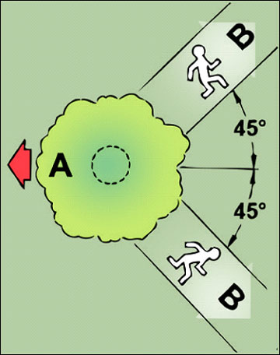
(1) Select and prepare the work area by clearing a primary escape path as well as a secondary (alternate) route before starting the cut. Make sure all obstructions (branches, rocks and equipment) are cleared from the escape paths before starting the cut;
(2) Be aware that the quadrant opposite the planned fall of the tree is extremely dangerous; and
(3) Choose an escape path that extends diagonally (45 degrees) away from the expected felling line, and always have an alternate retreat path to a safe zone.

- Safe Zones. The operator must carefully plan the route from the stump to the safe zone. Safe zones should be no less than 20 feet from the stump. If possible, the operator should stand behind another tree, preferably quartering back from the planned direction of the fall, and wait and watch at least 30 seconds after the tree hits the ground for whiplash branches and the scatter of broken tree parts.

- Street and Road Closure. If any part of the tree can fall into the street or road, the street or road should be closed off as part of the felling zone.

Felling Procedures

            - Clear the area around the tree of undergrowth, rocks, and debris.
            - Always look at the top of the tree for widow-makers, lodged trees, wires, and other hazards. Before making any cuts, the tree should be inspected for any metal objects such as spikes, nails or wire that can cause the chainsaw to kick back.
            - Remove any obstacles on the trunk that might interfere with felling. When removing unwanted limbs from standing timber, the basic safety rule is: Never limb above your shoulders; that is, do not attempt to cut off branches above the height of your shoulders.
            - Prepare a line of retreat 45◦ away from the line of fall. Be sure you are not hemmed in with underbrush or obstructions.
            - Before starting to cut, make sure no one is closer than two tree lengths away from felling operations.
            - For trees 6 inches in diameter or less, make one cut through the trunk. For larger diameter trees, the inexperienced chain saw operator should make two basic cuts: the undercut and the back cut. Advanced cutting techniques, such as plunge cutting, should only be done by experienced, professional loggers.
            - Give a timely warning understood by all employees, just before the back or final cut is started.
            - Never cut a standing tree completely through. Leave sufficient wood between the notch and the back cut for the tree to hinge on; otherwise, you may lose control of the tree and it could kick back.
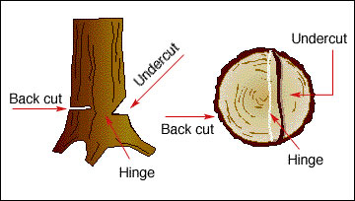
            - If too much hinge is left, the tree can split and possibly barber chair. This can result in injury or kill the feller. For more information check out: https://youtu.be/MJJYOCaOlqE
            - Never leave a lodged or hung tree; always push or pull it down with the aid of a skidder, etc. If it has to be left unattended for any length of time, properly mark it to indicate a danger area.
            - Never cut on days of high wind velocity.
            - Never climb or cut sections out of lodged trees.
            - Never leave a lodged tree, as any vibration from machinery or a sudden wind could bring it down on a crew member or an unsuspecting person.
            - Fell the lean of the tree whenever possible, and into clear areas.
            - Retreat from a falling tree at a 45◦ angle away from the direction of the fall at least 20 feet from the tree. If possible, stand behind another tree at the end of your retreat path.

Limbing a Tree

- Evaluate the fallen tree to see if it has become lodged or wedged in adjacent trees and has not fallen all the way to the ground, do not walk underneath the tree. It may fall without warning. Trees that are “hung” are especially dangerous and need to be removed by mechanical means. They can be pulled down with a cable and a tractor suitably equipped to protect against roll-over and falling objects.
- Once you have evaluated the obstacles and hazards and are ready to limb the tree, stand on the uphill side of the tree. Never stand on the downhill side of a fallen log. If you cut a branch that is holding the log in place, the log could roll downhill and trap you. Make sure you have good footing and are standing in a balanced position that allows you freedom of movement.
- Start at the bottom of the tree and work your way to the top, removing branches on the opposite side of the tree from you as you go. Whenever possible, always cut on the side of the log opposite from you. This places the log between you and the saw and provides additional protection for you.

Medical Availability
When chain saw operators are working in an area where medical assistance is not readily available (within 15-20 minutes), the supervisor must ensure a written plan exists for emergency response actions. The plan must include information about the nearest medical clinic and medical response capabilities.

