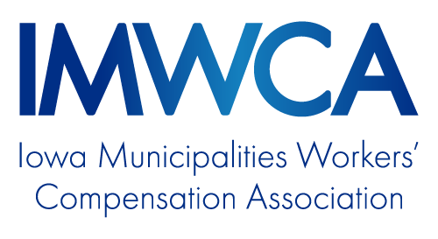
Slip, Trip & Fall Handbook

OVERVIEW
Overview 3
Weather Related Strategies 4
Vehicles and Equipment 6
Shop Safety 7
Stairs 8
Carpet, Cords and More 9
Elevated Work 10
Wet Floors 11
Health 12

Slip, Trip and Fall Handbook

Overview

Definitions
The National Safety Council provides the following definitions:
- Slips - where there is too little friction or traction between the footwear and the walking surface that causes sudden imbalance.
- Trips- when your foot collides (strikes, hits) an object causing you to lose your balance and, or, eventually fall.
Why the prevention of slips, trips and falls is important
National statistics:
- Largest source of direct costs of disabling claims.
- Slips, trips and falls make up 15 percent of all workers’ compensation claims.
- Slip, trips and falls account for 27 percent of workers’ compensation costs.
- The average slip and fall workers’ compensation claim costs nearly $25,000.
- 60 percent of lost workdays are due to slip and falls.
*statistical information from Bureau of Labor Statistics, National Safety Council, National and Flooring Safety Institute IMWCA statistics:
- Slips, trips and falls account for 25 percent of total workers’ compensation claims costs.
- Slips, trips and falls account for approximately 25 percent of total claims frequency.

National statistics show that the majority (60 percent) of falls happen on the same level resulting from slips and trips. The remaining 40 percent are falls from an elevated height. Same-level falls represent high frequency and low severity while elevated falls usually have low frequency and high severity.
Given the prevalent number and costs of claims due to slips, trips and falls, the Iowa Municipalities Workers’ Compensation Association (IMWCA) has developed this program using industry information to assist our members in developing and implementing strategies proven to prevent slip, trip and fall injuries. While the emphasis of this information is to protect employees from work-related injury, some of this information can also be used to prevent slip, trip and fall incidents involving the public visiting your buildings and facilities.

Weather Related Strategies

The State of Iowa has some diverse weather including ice and snow in the winter, frost in the spring and fall, and rain in the summer. Each of these weather-related variables represents a potential source for slips and falls.

Ice, snow, frost and rain can cause a reduction in traction between footwear and a walking surface. A reduction in traction can cause the foot to slip in an unintended direction which can result in a fall. Traction is measured in the Coefficient of Friction (COF). It takes a COF of .4 to .5 or better to have excellent traction. Surfaces covered in ice or melting snow can have COF as low as .1 when proper footwear is not worn. Leather soled shoes when damp and slightly warm create a film of moisture between the shoe and the surface. The moisture greatly decreases the COF and increases the chances of hydroplaning and slipping.

There are a number of sound strategies to follow to help reduce weather-related slips and falls. We will examine four of the key components.

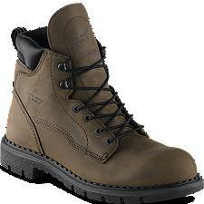
Footwear

Proper footwear suitable to the weather conditions is a key component. Properly selected footwear can significantly increase the COF in a given situation and decrease slip potential.

For people working outside, selecting a good work boot with a slip-resistant sole is a good place to start. Your local vendor can provide valuable information on the type of sole appropriate to the type of slip exposures you might encounter. For example, the soles needed to deal with oily wet floors might be different from the soles needed to deal with snow. In some extreme cases, regular slip-resistant soles may need to be augmented with cleats or other slip-resistant slip-ons. Selecting appropriate add-ons will depend on the exposure and the tasks being performed.

For people working inside but having to venture outside intermittently, there are a few strategies that can be followed.
- First, wear rubber slip-ons to provide traction to leather soled shoes. The slip-ons can also protect shoes against moisture.
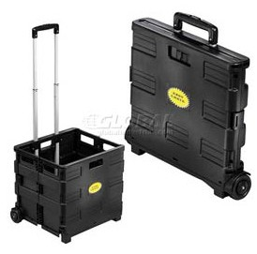
- Second, when slip-ons won’t work, such as in the case of high heels, wear weather appropriate shoes outside and wear a separate pair of shoes for inside the office. One item to consider with this option is to provide an area for employees to store their overshoes or boots when they are not being worn.

Free Hands

When navigating sidewalks, parking lots, or stairs during wet and slick conditions, it is important to keep hands as free as possible to help maintain balance and hold rails. Carrying materials in shoulder bags or in carts not only helps keep hands clear but also allows a clear view of the path of travel.

Take Your Time

A major factor in causing weather-related slips and falls is walking too fast for the conditions. Even with proper footwear, rushing can cause falls.

The best strategy is to allow adequate travel time to get where you are going. Being late is better than rushing and not getting there at all!
Check out this video: http://www.youtube.com/watch?v=Fbb3631ew_4
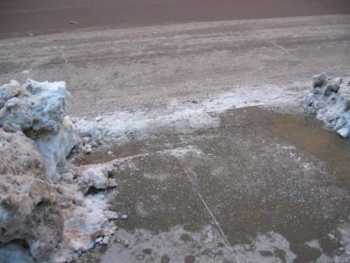

Maintenance of Walkways

The employer can also help diminish slip and fall potential by working with custodial staff to develop and implement a maintenance schedule to ensure
that snow and ice are removed from walkways as soon as possible. Then use intermittent inspections to safeguard against refreezing or new accumulation. The inspection process can also be used to monitor slick areas caused by rain runoff and frost accumulation in the fall and spring.

In summary, preventing weather-related slips and falls is a multi-faceted approach that requires diligence by both the employer and the employee. The employee should select and wear proper footwear for the conditions and make sure they give themselves adequate time for foot travel.

The employer should institute a walkway inspection program to ensure that surfaces are kept passable. Employers should also consider providing employees with shoulder bags or carts when their jobs require them to carry materials to and from work.

IMWCA Resources
- Suggested Online Training Course: Slips, Trips, and Falls

Entering and Exiting Vehicles and Equipment
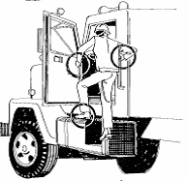

Although getting in and out of a vehicle seems like an innocuous undertaking, many people sustain serious injuries from slips and falls while trying this simple task. Getting on and off equipment and vehicles accounts for 1 out of every 4 injuries to those operating equipment or driving trucks; some of these injuries can be quite severe.

Mounting and dismounting large construction equipment such as dump trucks, motor graders and front loaders represents a year-round slip and fall exposure. Passenger-type vehicles also represent slip and fall exposures in certain situations.

The best means of preventing slips and falls from equipment is to use three points of contact to mount and dismount equipment. This process means that either two hands and one foot or one hand and two feet are in contact with the equipment steps and rails. For larger equipment,

the specific procedure for three points of contact may vary based on equipment design. To ensure proper mounting and dismounting procedures, an employer should consult with the manufacturer’s recommended procedure. In many cases, manufacturers may provide training videos on the recommended procedure.

Evaluate every truck and piece of equipment. The employer should provide additional steps, non-slip surfaces, and hand holds where necessary.

Once the proper procedure for a type of equipment is identified, it is important to train employees on that procedure.

Additional safety rules for getting on or off equipment or climbing in the cab of equipment:

Do
- Only climb on or get off when the equipment or vehicle is stationary
- Always mount or climb down while facing the truck or the equipment
- Make sure that the points of contact you are using are clear of debris and mud
- Only use points of contact that were intended to be used to climb on or dismount (hubs and such should not be used).
- Look for obstacles on the ground below before exiting

Don’ts
- Don’t climb on or get down with something in your free hand. Put it on the vehicle floor and reach for it when you reach the ground.
- Don’t rush to exit the equipment after a long run. Descend slowly, to avoid straining a muscle.
- Never jump out. You may land off balance or on an uneven surface, and fall.

For passenger-type vehicles such as cars, pickups and SUVs it is important to make sure you have firm footing with one or both feet before you put your entire weight on your feet. Maintain contact with the door, car ceiling or assist handle to develop the three points of contact. Remember that sand and oily spots can lead to slips and falls just like snow and ice. Always be aware of the type of surface on which you are stepping!

IMWCA Resources
- Sample YouTube Training Video:
www.interstatedriving. com/news/2010/04/safety-tip-three-points-of-contact/

Shop Safety

Maintenance shops are multi-operational sites that harbor the potential for numerous slip and fall exposures due to the equipment and materials used and the byproducts of the work.

Here is a list of some of the more common slip and fall exposures:
- Cords and hose left on the shop floor
- Wood and metal shaving accumulations
- Oil spots from mechanical work- may also include piles of oil-absorbing material
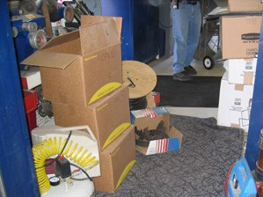
- Unsecured rugs
- Uneven steps
- Equipment or tools left in walkways
- Boards or metal strips that extend into the walkway
- Storing equipment without adequate walking space
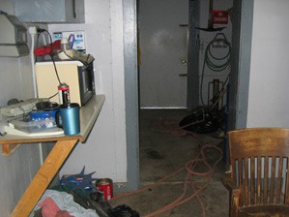
- Dirt and snow falling from stored equipment
- Poor lighting
- Uneven surfaces or protrusions due to drains, lift rails and thresholds
- Unsecured tools

To address these exposures, IMWCA recommends these strategies:
- Store hoses and cords on retractable reels. When possible have reels extend from the ceiling to keep them from lying on floors.
- Maintain good housekeeping practices.
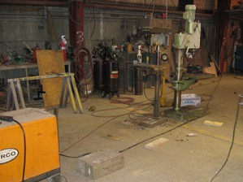
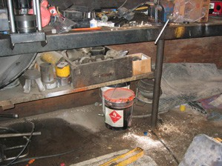
- Sweep floors regularly to remove shavings, oil dry and dirt accumulations.
- Clean up oil spots immediately.
- Remove boards and metal strips that extend into walkways.
- Store equipment and materials in a manner that allows space for walkways. This prevents someone from stepping over equipment.
- Inspect regularly to ensure that tools and materials are not left in walkways.
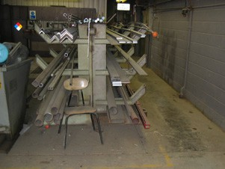
- Secure rugs so they lie flat on the floor.
- Keep stairs clear.
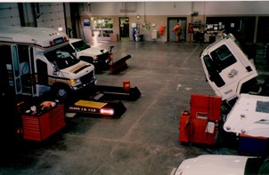
- Maintain good lighting.
- Mark uneven surfaces or protrusions on the floor with yellow paint.

Stairs

Throughout the day many people climb and descend stairwells at home, at work or in public. This simple task accounts for numerous falls each year that result in severe injury. This section will identify the causes associated with stairwell falls and what strategies can be used to prevent these occurrences.

The primary cause of stairwell slips and falls is the loss of balance. There are a few key reasons we typically lose our balance on stairs. Here are some points to remember when using stairs:
- Slow down going up or down stairs. Ensure a firm footing on each tread before taking the next
step.
- Use the railing to provide balance security.
- Keep your eyes on the path. Distractions can cause missteps.
- Do not carry items in your arms that obstruct the view of the steps. Not only can you misstep, but you will be unable to use the railing to catch yourself.
- Wear proper footwear. High heels, flip flops and slides can impede balance while climbing stairs.

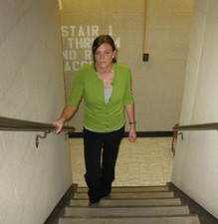
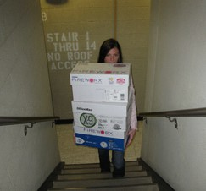
Correct Incorrect

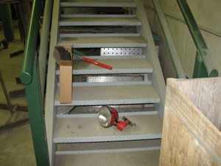

Proper maintenance of stairs is also important to slip and fall prevention. Accumulation of ice, snow and excessive sand on outdoor stairs can reduce proper footing. Frequently inspect stairs and clear away new accumulations as soon as practical.

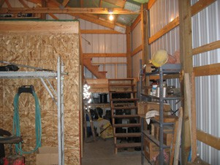
Slick wax, unattached or rolled carpet and items stored on stair treads can be trip hazards in offices or shops. Stair treads should be inspected frequently to ensure these conditions do not exist. High traction tape may be used to enhance the (COF) on treads. Specialty non-slip wax and other edgings are also viable options to improve traction on treads.

Stairwells should also be well-lit to ensure good visibility. Burnt-out bulbs or under-illuminated fixtures should be replaced immediately.

Finally, make sure that any set of stairs with three treads or more are provided with properly mounted handrails. Consult with the NFPA Life Safety Code to determine the handrail requirements for your stairwells.

Carpet, Cords and More

A common misperception is that there are no workplace hazards in places like offices, libraries or museums. The reality is there are a number of significant risks in these locations, and slips and falls are a major cause of injury here, too.

In office settings, some of the more common contributing factors are unsecured carpeting, cords strewn in walkways and under desks, drawers left open and materials stored under desks.

Carpets and rugs should be inspected frequently to ensure there are no rolls that create trip hazards. If rolls exist, the carpet should be restretched or replaced. Entry rugs should be adjusted to prevent rolls and the ends secured.

As more electronic equipment is used in offices, more cords are present. Newer buildings have been designed to accommodate the increase in cords and wiring, however, older buildings with fewer outlets and no means to convey wiring in the walls or ceiling may have to run cords and wires on the floor. To address this exposure, bridges should be used to cover cords and wiring across floors. The bridges should lie flat on the floor or be secured with tape.

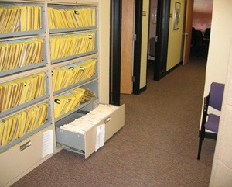
Cords and wires also represent a trip hazard when they dangle from the desktop to the floor. Employee’s feet can become tangled in unrestricted wires and cause employees to fall when they attempt to get up from their desk. Cords and wires should be placed in cord harnesses and secured to the desk to prevent dangling.

Another cause of office trips and falls are low-level filing drawers left open. Not only can these cause falls but the sharp edges can be a source of severe cuts. Be sure to close all drawers that are not in immediate use.

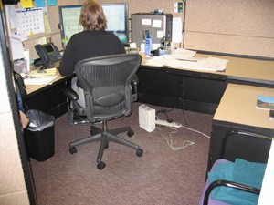
Probably the most important strategy for slip and fall prevention in the office environment is to train employees to maintain awareness of their surroundings. Keep eyes on the path ahead and look for potential hazards.

Elevated Work

Slips and falls from elevated work platforms like ladders, scaffolds and decks are not as frequent as other types of slips and falls but they tend to be very serious in terms of physical damage to the injured person.

Ladder-related falls are the most typical falls that we see in this group. Fall from ladders are a result of several factors that can include:
- Using a ladder that is too short for the task.
- Setting up a ladder incorrectly or in an unstable manner.
- Overreaching from a ladder.
- Walking up a ladder with a load in hand.

Employees who may use ladders for their jobs should be trained on the following points according to Occupational Safety and Health Administration:

• Proper selection of ladders for the task, i.e. height, weight limits and type.

• Inspection of ladders before use.

• Proper set up of ladders including securing to base if applicable.

• Properly ascending and descending ladders with three points of contact.

IMWCA has online training to assist with this training. Ladder manufacturers may also have other resources to assist with training, selection and inspection.

Another common and yet unfortunate cause of falls from elevated work platforms occurs when employees stand on chairs or other makeshift platforms. These platforms are not intended for elevated work. Do not allow chairs to be used in place of a ladder regardless of the height of the task.

Regarding falls from scaffolding, poor construction or lack of proper railings are two of the most common reasons falls occur. Always use only qualified employees to set up scaffolding. Inspect the scaffolding each day and ensure all rails are in place and properly secured when scaffolding is in use. Employees should always climb scaffolding using three points of contact on the scaffolding rungs.

For moving work platforms, use basket trucks or man lifts with proper fall protection. Never use the bucket of a loader as a work platform. Buckets are not designed for this task. Many serious injuries occur when employees are knocked out of the bucket.

Finally, when working from elevated decks, always ensure that the railing system is in place and that any gates or chains are in place before starting a task.

IMWCA Resources
- Suggested Online Training Course: Ladder and Scaffold Safety

Wet Floors

Slips and falls can occur anywhere when the potential of reduced traction exists. One element that contributes significantly to reduced traction is the presence of moisture on floors. Wet floors can occur in office buildings, shops, nursing homes, kitchens and any other location with impermeable flooring like tile, cement or marble.

There are several reasons that moisture occurs in these locations:
- Leaks from roof or plumbing
- Melting snow or ice carried in by footwear
- Housekeeping duties such as mopping or washing
- Condensation from washers
- Melting snow from equipment being serviced in shops
- Splashing from operations at water and wastewater treatment facilities

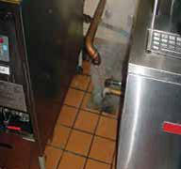 | 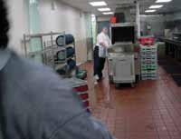 | 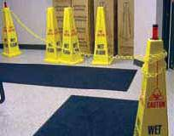
Drain pipe splashing excessive moisture | Wet kitchen floor | Warning signs and chain barrier to prevent

To reduce or eliminate moisture spots in walkways, follow these key, common sense strategies:
- Practice good housekeeping by immediately mopping up excess moisture.
- When cleaning wet floors, place warning signs in travel portions of walkways.
- Fix leaks immediately.
- Place carpets at building entries to catch melting snow and ice from footwear. Change out carpets frequently during winter months to prevent over saturation.
- Ventilate rooms with high humidity, like laundry rooms and kitchens.
- Provide slip-resistant mats in front of sinks, dishwashers and washer/dryers to keep water drips from accumulating.
- When possible use traction tape, textured paint or non-slip floor treatment in environments with heavy moisture potential, such as water and wastewater buildings.
- Wear proper slip-resistant footwear.
- Take your time when walking in areas that are generally wet, such as maintenance bays.
- Implement a reporting process that employees can use when they see a problem.

IMWCA Resources
- Sample YouTube Training Video: Slip and Fall in Kitchen Video: http://www.bing.com/videos/search?q=slips+trips+and+falls+in+kitchens&view=detail&mid=3E9C3F 7CDAB36D13D13E3E9C3F7CDAB36D13D13E&first=0

Health

Ice and snow, uneven walking surfaces and other contributing factors are generally the main causes of slips and falls. However, another causation rarely gets covered but one that is increasingly playing a growing role in slip and falls. That causation is your health!

In a review of IMWCA slip and fall claims, health-related conditions were a contributing factor in either the cause or severity of the injury. In this section, some health issues will be discussed. First, obesity played a role in over half of the largest slip and fall claims. Overweight individuals with limited mobility were more susceptible to tripping due to problems associated with limited flexibility and balance. Obese individuals tended to suffer more acute knee and back injuries compared to other workers.

Second, diabetics had a higher than average number of falls due to low blood sugar events that caused disorientation or fainting. Employers and employees must be vigilant about monitoring the employees’ glucose levels. This may include training for both parties on what to watch for as warning signs.

Third, medications, such as cold medicines and cough syrup, can affect your basic motor skills and cause imbalance. Employees taking medications that can affect their performance should report this to their supervisor. If an employee is unable to safely perform the functions of their duties due to medication, then the employee should use sick days until they are cleared for duty.

Finally, sleep deprivation can affect your balance in a manner similar to medications. Your balance and awareness can be impeded if you are tired. Making sure employees are well rested. If they appear overly fatigued, then the employee should be reassigned or sent home.

In summary, besides a safe and compliant workplace, employee health also affects the probability of slips and falls in the workplace. Employers should monitor their employees to ensure they are physically capable of doing the job and provide assistance to those with morbid conditions to control potential problems. If employees are having problems with slips and falls, a functional capacity exam might be in order. Always be sure to consult with your employment attorney or Human Resources professional for guidance.

