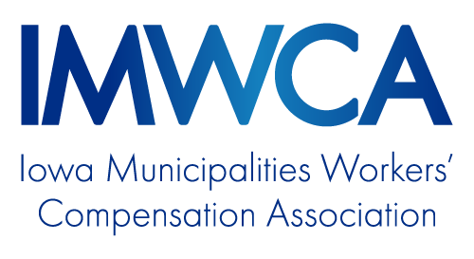

MODEL PROGRAM:
Seatbelt/Restraint Policy

OVERVIEW
Purpose 1
Leadership and Accountability 1
Policy 1
Employee Information and Training 1

Seatbelt/Restraint Policy

Purpose
This policy was created to protect the safety of our employees while operating official vehicles, equipment, personal and rental cars on official business.
Copies of this policy and procedures will be accessible to employees at location.

Leadership and Accountability
Name or Position will be responsible for enforcing and annually evaluating the seatbelt/restraint policy of their department.
Employees are accountable for following the policy and ensuring that other occupants of the vehicles or equipment they operate abide by the policy.

Policy

It is the policy of name of member that all employees operating official vehicles, equipment, personal and rental cars on official business and other occupants use seatbelts and shoulder restraints.
Employees operating on and off-road equipment with a Rollover Protective Structure (ROPS) shall use seatbelts when operating the equipment.
Employees are also prohibited from riding in or on parts of a vehicle not designed for human occupancy. This includes but is not limited to pick-up and truck boxes, fenders, steps and bumpers. This also applies to trailers, ATV dump boxes and lift buckets.
Failure to comply with these rules is a violation of name of member safety policies, which is cause for disciplinary action.
Employees should refer questions or comments about this policy to Name or Position.

Employee Information and Training

All employees will be trained on the policy. Training will be documented and the records stored at location.

