

MODEL PROGRAM:
Fixed and Portable Ladder Safety

Purpose 1
Leadership and Accountability 1
Definitions 1
Inspection and Maintenance 1
Fixed Ladder Inspection and Maintenance 2
Proper Use 2
Employee Information and Training 2

Fixed and Portable Ladder Safety

Purpose
This program was created to ensure the safety and health of our employees while using fixed or portable ladders.

Leadership and Accountability
Each employee will be responsible for daily inspections of the ladder or ladders prior to use. It is the employee’s responsibility that the ladder is in good working order, if not, report it to the supervisor. The supervisor will replace the ladder if it is damaged or defective.
NEVER USE A DEFECTIVE OR DAMAGED LADDER

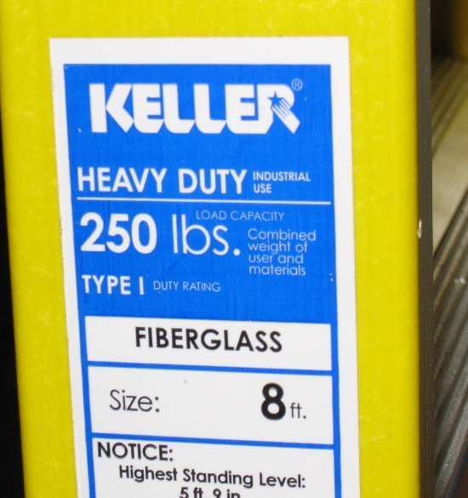
Definitions
- Fixed Ladder: a ladder that is permanently attached to the side of a structure or vehicle.
- Portable Ladder: any ladder that is transportable by any means, not just physically carry.
- Rungs or Steps: any horizontal section within a ladder used to climb the ladder.
- Step Ladder: a short folding ladder with flat steps and a small platform.
- Duty Rating: the working load of the ladder.

Inspection and Maintenance
- Examine every ladder prior to use for:
- Splinters, bends, cracks, or any missing or damaged rivets.
- Rungs or Steps are in good shape.
- Bracing members (step ladder) are in place, and are in good shape and lock into position.
- All labels are in place and are readable. If they are not, the ladder should not be in use.
- DO NOT paint ladders.
- If the ladder is questionable during inspection, the ladder should not be used, tag it “out of service”, and have a competent person decide if the ladder should be repaired or discarded.
- Do not use ladders as barricades, ramps and scaffold runs.
- Ladders should be stored and secured to a wall to prevent tipping. Dropping a ladder can damage the fiberglass rails on the ladder, and loosen the rivets, or rungs. If it is an aluminum ladder it could bend and crease the ladder.

Fixed Ladder Inspection and Maintenance

Examine every ladder prior to use for:
  - Rusting through on welds, look at the rungs on the ladder, and attachment points, and anchorage points.
  - Separating welds, or missing welds.
  - Rusting through on the rails.
  - Damage to the ladder.
  - Missing or defective fall protection. See Fall Protection model for reference.
  - Fall Protection that is defective. Safety line missing (if put in prior to November 2016), Cage broke or missing, safety pit defective, and defective or damaged anchorage points.

Proper Use
It is the responsibility of the user of the ladder, either a portable ladder or a fixed ladder to properly use them. Make sure, if it is a portable ladder, that it will not fall, either slide out from under the user, or collapse while in use. Do not put the ladder on a box or a shelf then climb on the ladder. Proper set up is key to safe use of the ladder.
For Fixed Ladders, proper inspection is key. Make sure there is not any items in your hands as you are climbing the ladder, either portable or fixed.
For more information on portable or fixed ladders, you can call the Loss Control Department here at IMWCA, or refer to OSHA, at www.osha.gov.

Employee Information and Training
The employer shall provide training so that all employees acquire the understanding, knowledge, and skills necessary to safely perform their duties. All training must be documented.
  - See IMWCA Online training

