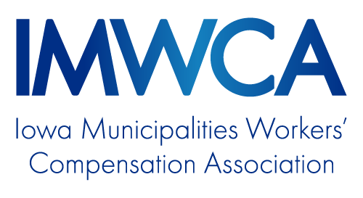
Hearing Conservation Policy

OVERVIEW
Purpose 1
Leadership and Accountability 1
Noise Audits 1
Audiometric Testing 1
Hearing Protectors 2
Employee Information and Training 2
Record Keeping 2
NOISE AUDIT WORKSHEET 3

Hearing Conservation Policy

Purpose
This policy was created to protect the hearing of our employees while they are at work. This policy covers what occupational exposures employees may have to loud sounds and how employees will be protected from the exposures while at work.
Copies of this policy will be accessible to employees at location. Each employee exposed to noise above the threshold will be trained on this policy.

Leadership and Accountability
Name or Position will be responsible for annually evaluating the hearing conservation policy effectiveness, monitoring noise levels within the facilities and selecting appropriate hearing protection.
Employees are accountable for the proper care, maintenance, and proper use of the hearing protection.
Employees should refer questions or comments about this policy to Name or Position.

Noise Audits
Audits may be conducted by using either a phone Apps or a decimeter to determine if a location is at or near 85 decibels.
All locations and equipment will be audited twice yearly to determine if it exceeds 85 decibels.
All locations and equipment that exceed the 85-db limit shall be conspicuously marked to notify employees of the risk.

Audiometric Testing
- Audiometric testing will be performed on all employees whose exposures equal or exceed an 8-hour time-weighted average TWA of 85 decibels (Action level).
- Audiometric testing will be provided at no cost to employees.
- Audiograms will be conducted at least annually after obtaining the baseline audiogram for each employee exposed at or above an 8-hour time-weighted average of 85 decibels.
- The (hearing conservation leader) will maintain a record of all employee audiometric test records. This record will include:
  - Name and job classification of the employee.
  - Date of the audiogram.
  - The examiner's name.
  - Date of the last acoustic or exhaustive calibration of the audiometer.
  - Employee's most recent noise exposure assessment.

Hearing Protectors
The supervisory staff shall ensure the hearing protectors are worn:
  - By any employee who is subjected to sound levels equal to or exceeding an 8-hour TWA of 85 decibels.
  - By any employee who has experienced a persistent Standard Threshold Shift and who is exposed to 8-hour TWA of 85 decibels or greater.
  - By any employee who has not had an initial baseline audiogram and who is exposed to 8-hour TWA of 85 decibels or greater.
Employees will be given the opportunity to select their hearing protectors from a variety of suitable hearing protectors at no cost to them.
Employees will be held accountable for properly using and maintaining the equipment furnished.

Employee Information and Training
Training will be provided to all employees so they acquire the understanding, knowledge, and skills necessary for the safe performance of their duties. Training will be documented and the records stored at location.
  - See IMWCA Online Training Course

Record Keeping
- Noise exposure records will be retained for two years.
- Audiometric test records will be retained for the duration of the affected workers’ employment and available to employees upon request.

Noise Audit Worksheet

Location:

Last updated:

Updated by:

Location or Equipment Noise Monitoring Method Noise Level

Page: ______ of _________

