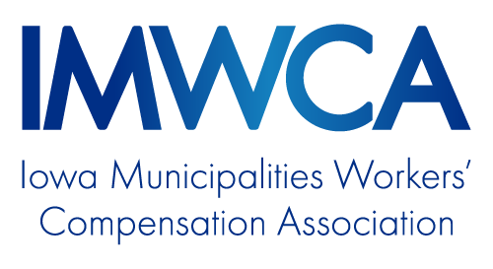

MODEL PROGRAM:
Hazardous Communications Policy/
Right to Know

OVERVIEW
Purpose 1
Leadership and Accountability 1
Container Labeling 1
Chemical Inventory List and Safety Data Sheets 1
Unlabeled Pipes 1
Employee Information and Training 1
Outside Contractors 2
Hazardous Materials/Chemical Inventory Form 3
Hazardous Communications Update

Purpose
This policy was created to protect our employees who may handle hazardous chemicals while they are at work. This policy covers what occupational exposures employees may have to hazardous chemicals and how employees will be protected from the exposures while at work.
Copies of this policy will be accessible to employees at location. Each employee exposed to hazardous chemicals as part of their job duties will be trained on this policy.

Leadership and Accountability
Name or Position will be responsible for annual review of the policy and updating the SDS sheets or book when new chemicals arrive. Name or Position will review employee hazardous communications training, purchase of equipment and incident review of injuries or illness involving chemical exposures. Chemical inventory list (SDS book) should be updated annually.
Employees are accountable for the proper care, maintenance, and proper use of the personal protection equipment. Employees must know where the SDS sheets/book is kept and how to read them.
Employees should refer questions or comments about this policy to Name or Position.
Container Labeling
Each department will maintain an updated chemical inventory for that department.
Each chemical in the inventory shall have a corresponding SDS. The sheets shall be organized in a manner that the SDS for a chemical appears in the same order as it appears on the inventory list. The person designated to maintain the inventory shall also maintain the SDS.
When a chemical is removed from use and from the chemical inventory, the SDS must also be removed. Retired SDS must be retained and stored for 30 years from the date of removal from service. Date of removal must be noted on the upper right-hand corner of the SDS.
Unlabeled Pipes
Employees may be required to work in areas where chemicals are contained in unlabeled pipes. When labeling is not feasible, employees shall be informed of the contents of the pipes (e.g. Chlorine). Employees should also be instructed on the proper measures to reduce or eliminate exposures.

Employee Information and Training
The employer shall provide training so that all employees acquire the understanding, knowledge, and skills necessary for the safe performance of their duties. This includes reading and interpreting safety data sheets
- See IMWCA Online training for Hazardous Communication and Globally Harmonized Systems
Outside Contractors
A firm or individual contracted by Enter entity name is responsible for meeting all contractual agreements and for providing a safe and healthy workplace for its employees in compliance with applicable OSHA standards.
Contractors must make copies of their hazardous communications policy and all SDS for chemicals brought on site available to name of responsible person. Contractors who fail to follow the policy requirements will be asked to leave the premises. Contractors with an insufficient policy will not be allowed to begin work until their policy meets or exceeds the requirements of the applicable OSHA standard.

Hazardous Materials/Chemical Inventory Form

Location:

Last updated:

Updated by:

SDS on file
Chemical name Yes/No Quantity Location

Page: ______ of _________

